1. Introduction & Purpose
This document describes where the Collaborative Planning, Forecasting, and Reconciliation (CPFR) program stands today, what we learned through execution, and where we are taking the program in 2026 and beyond. Its goal is to create a shared understanding across leadership and partner teams of what CPFR is now, how it has changed over the past year, and what must be true for it to continue to scale in a sustainable way.
Stated simply, we believe CPFR is Chewy’s operating model for how we work with vendors, aligning teams around shared, governed data and structured collaboration to strengthen vendor relationships, unlock inventory, and sustain Chewy’s core KPIs as the business grows.
CPFR has moved beyond being a mechanism for sharing data and has become a core part of how Chewy works with vendors. It now shapes how risks are identified, how priorities are aligned, and how action is taken across teams. Over time, CPFR is intended to operate as a durable capability rather than a standalone program—providing a consistent data foundation for vendor collaboration and enabling teams to move from looking backward at results to looking forward at emerging risks and tradeoffs. By aligning teams around the same facts and signals, CPFR reduces friction, speeds up decision-making, and creates a foundation for more effective planning as adoption and maturity increase.
2. Scope, Ownership, and Guardrails
CPFR is responsible for how Chewy works with vendors around planning, forecasting, and inventory risk. This includes owning the data that is shared with vendors, defining how risks are identified and reviewed, and setting the standard ways teams collaborate. In practice, that means CPFR defines regular CPFR meetings, manages structured forecast and input reconciliations, provides tools and processes to consistent data, and establishes clear escalation paths so issues are surfaced, discussed, and acted on consistently.
CPFR also serves as the primary coordination point for vendor collaboration across Supply Chain, Merchandising, and other partner teams. It provides a shared operating structure and common set of signals that those teams can align to, rather than each group working from different data or processes. CPFR’s role is to enable Instock Managers with clear, automated signals so they can focus on decision-making instead of manually pulling or assembling data.
A core principle behind how CPFR designs its capabilities is proximality. Simply put, value is lost when vendors have to wait for information or when ISMs have to assemble raw data before they can act. CPFR capabilities are designed to move insight and action closer to the point where decisions are made—allowing vendors to self-serve where appropriate and enabling ISMs to inspect signals rather than build them.
CPFR does not own buying decisions, replenishment logic, forecast creation, or vendor execution. Those responsibilities remain with their relevant teams. Vendor Compliance is treated as a closely partnered but separate function. CPFR will work with Vendor Compliance to ensure vendors experience a consistent, coordinated process, while ownership and enforcement remain with the Vendor Compliance organization. More broadly, CPFR influences outcomes by ensuring inputs are accurate, timely, and governed, and that risks are identified early.
3. 2025 Retrospective — What Changed
The most significant change in 2025 was an intentional shift in how Chewy works with vendors. CPFR moved from being primarily a data-sharing mechanism to a defined operating model that sets clear expectations for vendor engagement, accountability, and follow-through. Rather than focusing only on what information is shared, CPFR now defines how Chewy and vendors work together, standardizing cadence, expectations, and review mechanisms to drive greater consistency and accountability across vendors, regardless of size or maturity.
Regular vendor interactions were formalized into CPFR meetings for our top 60 vendors by COGS across instock. Vendors that had previously engaged through ad hoc conversations or inconsistent touchpoints were required to move to a recurring cadence. Weekly, biweekly, or monthly business reviews became the standard forum for aligning on forecasts, identifying inventory risk, and addressing operational issues. These meetings were no longer optional or loosely structured—they became the primary mechanism for collaborative planning.
The shift to CPFR as an operating behavior came first; the tools followed. As expectations around cadence, accountability, and collaboration became clearer, CPFR invested in capabilities that could support that model at scale. Apollo, weekly summaries, attendance tracking, and standardized agendas were introduced to reinforce structured conversations and visible follow-through. The 2026 roadmap continues this pattern, with a strong emphasis on communication, expectations, and vendor experience to sustain the behavior as scale increases.
In parallel, CPFR delivered several foundational capabilities in 2025. These included expanding Apollo as a centralized analytics tool for vendor discussions, introducing a structured approach to forecast reconciliation, adding SKU audit tooling, and automating large portions of CPFR email intake and summarization. Vendor tier logic was standardized to ensure consistent definitions and outputs across the program.
All of this occurred while the program absorbed significant operational growth. In 2025, CPFR handled more than 400 vendor maintenance requests and nearly 200 VPP tickets, consolidated three separate vendor-management systems into a single platform, and improved reporting reliability such that Tier 1 deliverables moved from mid-week to the start of the week. This shift reclaimed time for ISMs to focus on planning rather than reacting to data issues. At the same time, CPFR supported a major enterprise migration from Vertica to Snowflake, revising and validating over 2,100 lines of production query logic while maintaining uninterrupted service to vendors.
To support better investment decisions going forward, CPFR also developed a quantified entitlement framework during 2025 focused on the CPFR Data Platform and CPH Portal initiative. This work, grounded in user research and operational data, established a practical baseline for evaluating return on investment within that scope. Because the analysis focused on a single initiative rather than the full CPFR footprint, it represents a conservative view that can be expanded and refined as additional capabilities are evaluated using the same approach.
4. CPFR Today — Current State
CPFR today operates at a large and growing scale, but much of the way it works was not originally designed for the size and complexity of Chewy’s current vendor ecosystem.
Each week, CPFR distributes inventory, forecast, and operational signals to more than 2,300 vendors. Over the past year alone, more than 1,100 new vendors were added to the program, including significant growth in direct-ship relationships. Looking ahead, CPFR is on a path to support roughly 5,000 active vendor relationships. This level of growth makes it clear that coordination-heavy ways of working will not scale.
While some CPFR workflows are automated today, many still rely on manual coordination. Reports often require validation and re-sends, and changes to vendor contacts, tiers, or scope create ongoing maintenance work. The resulting volume of tickets and maintenance requests is not viewed as an acceptable steady state. Instead, it highlights process and tooling gaps that the 2026 platform and automation initiatives are designed to address.
Access to CPFR data is also fragmented. Information is spread across emailed reports, dashboards, direct queries, and local tools. This creates version drift and timing inconsistencies, which slows collaboration and reduces confidence in the data. As a result, conversations with vendors and across internal teams often begin by reconciling numbers rather than focusing on decisions and actions.
To manage scale and engagement, CPFR uses a tiered model that defines both the level of data shared and the depth of collaboration.
Tier 3 (Baseline Coverage) — 2,241 vendors
- Broad vendor coverage with minimal operational overhead
- Data provided: current-month forecast and next six-month forecast
Tier 2 (Structured Engagement) — 72 vendors
- Same forecast horizons as Tier 3
- Supported by more structured CPFR workflows and higher-touch engagement
- Represents the largest operational burden today due to limited automation
Tier 1 (High-Impact Relationships) — 9 vendors
- Same forecast horizons as other tiers
- Deeper, more frequent engagement across CPFR processes
- Specialized inspection and cadence to manage complexity
5. 2026 Deliverables — Where CPFR Is Going
The priority for 2026 is scale. CPFR must be able to support a much larger vendor base without adding proportional workload for Chewy teams, while also improving data trust, collaboration quality, and how quickly decisions can be made.
At a program level, CPFR is focused on three outcomes: enabling vendors to self-serve from governed data, eliminating routine manual coordination, and shifting from looking backward at issues to identifying risk earlier. A key change in 2026 will be standardizing how CPFR tools and workflows are used across Instock teams. In 2025, teams had flexibility in how tools were adopted; in 2026, CPFR will establish clearer expectations around scope, cadence, and execution so ways of working are consistent.
The initiatives below are designed to address two needs at the same time. First, they resolve the operational friction exposed in 2025, such as manual coordination, reconciliation gaps, and inconsistent usage. Second, they build durable capabilities that allow CPFR to scale with consistency and depth over the long term.
Unified CPFR Data Platform
CPFR is building a single, governed data platform in Snowflake that serves as the authoritative source for vendor-facing metrics. This platform provides daily, consistent snapshots of data and removes time-of-day drift. It underpins how CPFR shares information both internally and with vendors, and replaces fragmented, manual data access patterns.
CPFR Vendor Portal (via CPH)
The vendor portal provides vendors with secure, always-on access to CPFR data and supports self-service management of contacts and preferences. While email will remain available as a transition mechanism, the portal becomes the primary experience for vendor collaboration. Beyond delivering data, it creates a consistent place for vendors to review signals, prepare for CPFR meetings, and engage with Chewy through defined workflows. The portal is designed to expand over time, including tighter alignment with Vendor Compliance and the ability to tailor experiences for different vendor segments.
Forward-Looking Risk and Decision Support
CPFR is shifting from retrospective reporting to earlier identification of risk. Standardized definitions and scoring for out-of-stock risk, backorder risk, and constraint exposure will support more proactive inspection and action. This work aligns with the Instock team’s forward-looking PDP OOS efforts.
In parallel, CPFR will extend decision support beyond static reporting. Initial work focuses on predictive out-of-stock signals to surface emerging issues sooner. Over time, CPFR will introduce more advanced scenario analysis, allowing teams to test assumptions and understand tradeoffs before decisions are made. These capabilities will be introduced deliberately and expanded only after they prove value.
Reconciliations
Reconciliation remains a core inspection capability. Forecast reconciliation, introduced in 2025, will mature in 2026 by aggregating exceptions over time to distinguish isolated issues from systemic misalignment across vendors, SKUs, or categories, while becoming a standardized mechanism for vendor interaction in weekly and monthly meetings.
CPFR is also expanding reconciliation into catalog and input health in partnership with MerchOps and new product launch teams. This includes improving upstream processes to prevent catalog defects and implementing audits and alerts to surface issues early, before they create downstream planning or execution problems.
Inclusive Extensibility
As CPFR scales, its capabilities will be built as modular components that can be reused across different vendor types and business areas, such as direct-ship, emerging vendors, and specialized verticals like RX and Cold Chain. Rather than relying on rigid tiers, teams will assemble the appropriate metrics and workflows for each use case from a common set of governed building blocks. This approach avoids one-off solutions, keeps the system easier to explain and maintain, and allows CPFR to scale without fragmenting its operating model.
Communication and Engagement
As CPFR scales in 2026, communication is treated as a core deliverable, not something that happens incidentally as tools are built. Clear, consistent communication is how CPFR aligns teams, drives adoption of new capabilities, and ensures work translates into action.
Internally, CPFR will run a regular set of forums with Instock teams and leadership. These sessions are designed to review what is in progress, surface risks early, and align on priorities before changes are launched. They will also be used to set clear expectations for how CPFR tools and workflows are used, define which vendors and teams are in scope and why, and secure leadership alignment ahead of rollout. The intent is to remove ambiguity and ensure consistent execution across teams.
Externally, CPFR will anchor vendor collaboration through structured CPFR meetings and a recurring vendor-facing survey. Vendors will have clear expectations around meeting cadence, preparation, and participation, reinforcing CPFR as the standard forum for collaborative planning with Chewy. The survey and meeting feedback provide a structured way to understand how CPFR is landing with vendors and where friction exists.
Together, these communication mechanisms support a broader goal: delivering a differentiated, high-quality vendor experience. Leadership has set a “white-glove” standard for how Chewy works with vendors, and CPFR’s communication model is designed to reinforce trust, consistency, and reliability. Feedback from these channels will inform refinement and improvement over time, but will not dictate program direction on its own.
6. Measuring Success
Historically, CPFR has struggled to consistently define and measure success at a program level. Success was often inferred from downstream outcomes, tool launches, or viewed through team-specific lenses, rather than tracked through a shared set of signals. As CPFR has grown in scope and scale, this lack of a common measurement framework has made it harder to understand what is working, what is not, and where to focus improvement efforts.
In 2026, CPFR will use a defined set of measures to evaluate whether the program is delivering on the 2026 outcomes. These measures are intended to support prioritization, guide course correction, and confirm that changes to tools and ways of working are producing meaningful impact. We will develop a method to infer CPFR impacts on Instock KPIs. Previously, there have been attempts to assign vendor KPI improvements to CPFR, yet it is difficult separating CPFR process improvement against the impact an ISM makes working with their vendor. However, we know CPFR is a factor to vendor improvement and we will determine a method to quantify the impact of the program to our KPIs.
At a high level, success will be assessed across two dimensions.
Engagement focuses on whether CPFR capabilities are being adopted and used as intended. This includes how often vendors access and use CPH self-service features, and internal teams’ access and usage with core tools. Engagement will also be informed by survey feedback and signals from CPFR meetings, which provide context on how the program is landing with vendors and internal stakeholders. These inputs will be used alongside other measures to validate success.
Operational leverage is evaluated through two lenses: decision velocity and experience.
Decision velocity focuses on how quickly CPFR helps teams move from identifying risk to making and acting on decisions. This includes reducing the time between a risk being flagged and an action taken, measured through faster actions on alarming and proactive alerts, fewer steps required to resolve routine issues, and shorter cycles from insight to decision.
Experience focuses on reducing friction and unnecessary handoffs in day-to-day work. This includes measurable reductions in vendor inquiries that require Chewy intervention, tracked through decreases in vendor ticket submissions, as well as reductions in the time ISMs spend assembling data versus inspecting signals, measured through time study comparisons conducted over the course of 2026. Together, these improvements indicate that work is moving closer to the point of influence, enabling smoother collaboration with vendors and more effective use of CPFR tools.
Some of these signals are influenced jointly with Merchandising, MerchOps, and other partner teams. They are used to guide collaboration and improvement across functions, rather than to assign ownership or accountability to any single team.
7. FAQs
What does being on CPFR mean?
Being on CPFR has two distinctions: 1) being on a data tier of outputs, such as Tier 1, 2, and 3 where they automatically receive data respective to their tier via email; and 2) they are considered a “CPFR” vendor, which sets the expectation for how ISMs interact with them, including structured meetings, forecast reconciliations, and a higher level of touch than non-CPFR vendors.

What is the current guidance on who should be a CPFR vendor?
The CPFR team has the following guidance on how we consider the data share tiers and the vendor’s size: TBD

How do I add a vendor to CPFR?
Vendors will automatically be added to Tier 3 of CPFR data share. An ISM or leader can decide to change a vendor to Tier 2 or Tier 1 data sharing based on the vendor’s size or strategic importance.

How is CPFR different from Replenishment?
Replenishment executes buying decisions. CPFR governs the data, risk, and collaboration inputs that shape those decisions.
Why not rely solely on VDS?
VDS serves premium analytics use cases. CPFR must support a broader vendor cohort with consistent, governed access.
What happens if CPFR does nothing?
Manual effort grows, data trust erodes, and CPFR becomes a bottleneck rather than an enabler of scale.
8. Appendices
Appendix A: Data Share and Tiering Overview
Tiering and data provided:
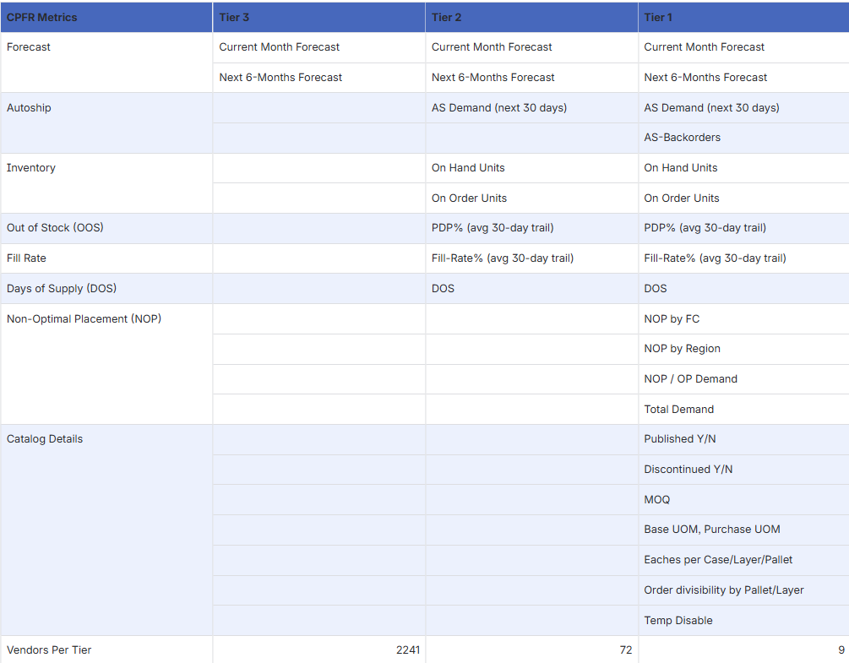
CPFR Vendors and their Tiers:
MC1 | Vendor | CPFR Tier
Consumables | Blue Buffalo | Tier 1
Consumables | Ethos | Tier 1
Consumables | Mars | Tier 1
Consumables | Nestle Purina | Tier 1
Consumables | Post | Tier 1
Healthcare (Non-RX) | Royal Canin | Tier 1
Consumables | Smucker's | Tier 1
Consumables | Wellness Pet | Tier 1
Hardgoods | Earth Rated | Tier 2
Hardgoods | Furhaven | Tier 2
Hardgoods | KONG | Tier 2
Consumables | Stella & Chewy's | Tier 2
Consumables | Whitebridge | Tier 2
Hardgoods | Angel Care | Tier 3
Hardgoods | BARK | Tier 3
Hardgoods | Benebone | Tier 3
Hardgoods | Catit | Tier 3
Exotics | Central Equine | Tier 3
Exotics | Central Exotics | Tier 3
Consumables | Champion | Tier 3
Consumables | Church & Dwight | Tier 3
Consumables | Clorox | Tier 3
Exotics | Compana | Tier 3
Consumables | Diamond | Tier 3
Consumables | Hartz | Tier 3
Exotics | Healthy Pet | Tier 3
Healthcare (Non-RX) | Hills | Tier 3
Consumables | Inaba | Tier 3
Hardgoods | K&H | Tier 3
Exotics | Kalmbach | Tier 3
Hardgoods | Midwest | Tier 3
Hardgoods | Multipet | Tier 3
Healthcare (Non-RX) | MWI | Tier 3
Healthcare (Non-RX) | Native Pet | Tier 3
Healthcare (Non-RX) | Naturvet | Tier 3
Healthcare (Non-RX) | Nordic Naturals | Tier 3
Healthcare (Non-RX) | Nutramax | Tier 3
Exotics | Nutrena | Tier 3
Hardgoods | Nylabone | Tier 3
Hardgoods | Outward Hound | Tier 3
Healthcare (Non-RX) | Pawfy | Tier 3
Healthcare (Non-RX) | PetHonesty | Tier 3
Healthcare (Non-RX) | PetLab | Tier 3
Hardgoods | Petmate | Tier 3
Hardgoods | Petsafe | Tier 3
Healthcare (Non-RX) | PPVD | Tier 3
Healthcare (Non-RX) | ProDen | Tier 3
Hardgoods | ROLF_HAGEN | Tier 3
Hardgoods | Ruffwear | Tier 3
Consumables | Spectrum | Tier 3
Healthcare (Non-RX) | StrellaLab | Tier 3
Healthcare (Non-RX) | Vetnique | Tier 3
Healthcare (Non-RX) | Vetoquinol | Tier 3
Healthcare (Non-RX) | VetriScience | Tier 3
Hardgoods | Wee Wee | Tier 3
Consumables | Weruva | Tier 3
Healthcare (Non-RX) | Zesty Paws | Tier 3

Appendix B: Tool Inventory and Usage
Apollo Usage – data excludes username spalmer5

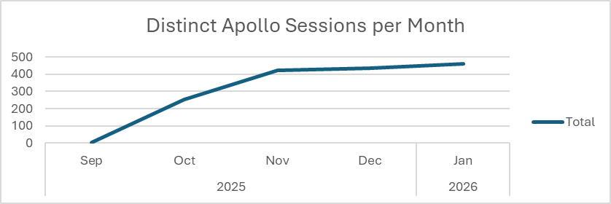
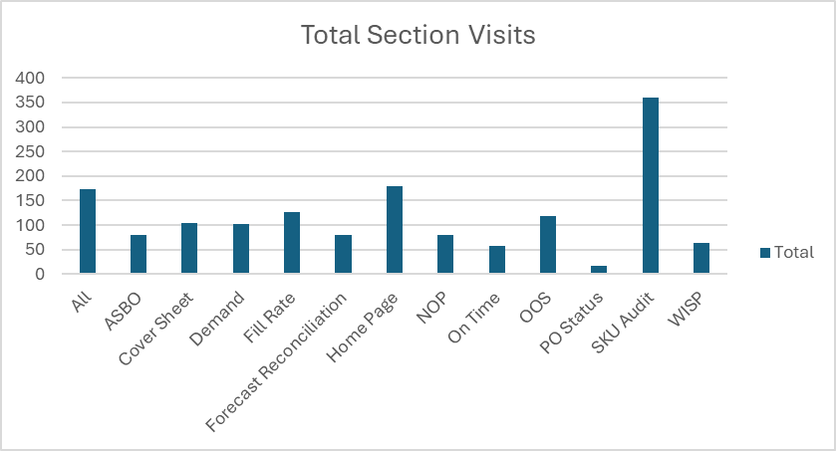
Appendix C: Vendor Feedback and Entitlement Evidence (Summary)
Consumables Vendor Survey – July 2025.
This survey will be used as a base in the 2026 creation of the CPFR Survey. It provides vendors with a single page of questions that can be answered in less than two minutes, focusing on specific actions, data sharing, and experiences the vendor has during their CPFR meetings. Coordination with ISMs was integral to the success, as they also pushed the vendor to complete the survey in their calls.
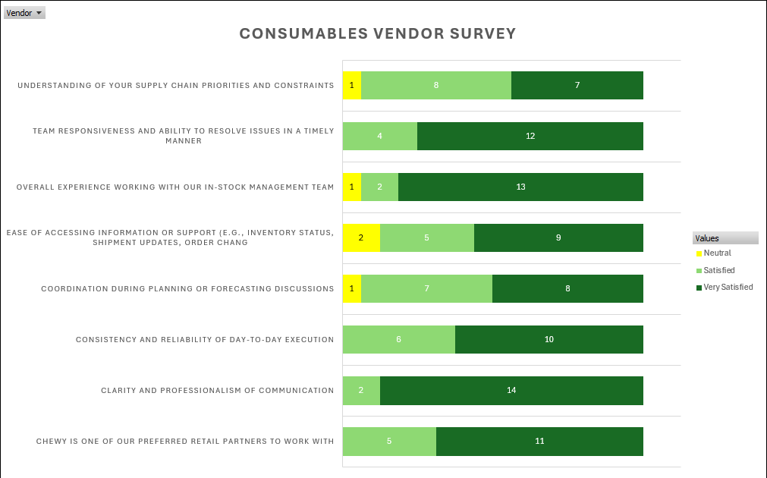
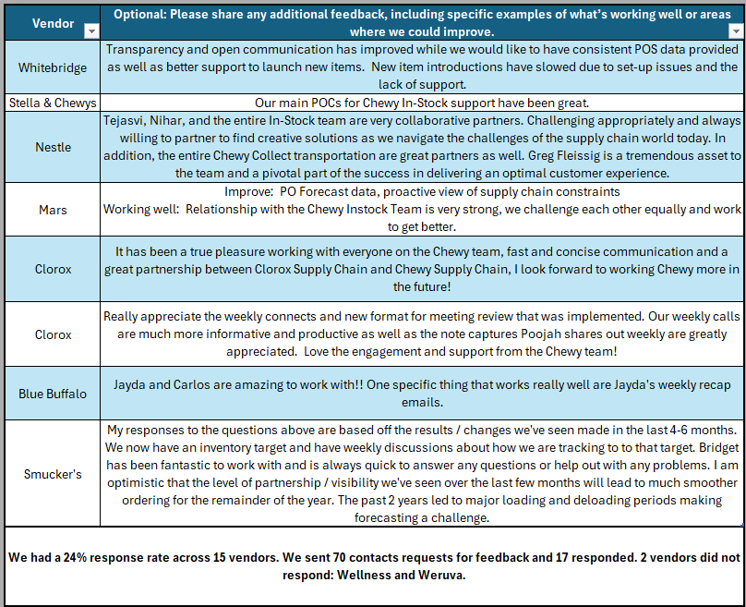
Appendix D: Entitlement Summary
While the entitlement that follows was scoped specifically for the CPFR Platform / CPH Portal project, virtually all CPFR projects deliver one or more of the benefit classes presented here:
Purpose & Context
CPFR currently delivers vendor-facing insights through weekly emailed reports, manual coordination, and limited on-demand tools. While workable at smaller scale, this model fragments data access, consumes internal capacity, and does not scale cleanly to the thousands of vendors required to support Chewy’s growth.
The CPFR Platform & Portal establishes a governed data foundation paired with a vendor-facing experience in Chewy Partner Hub (CPH):
- A centralized CPFR data platform delivering consistent, daily snapshots
- Secure, always-on vendor access through CPH
- Vendor self-service for contact management and distribution preferences
- Alignment with Vendor Compliance and Chargeback portal capabilities
Business Value
Together, these capabilities deliver value across four dimensions:
- Operational efficiency: Reduced manual data prep, reconciliation, and rework
- Vendor enablement: Faster access to consistent data, improving collaboration and responsiveness
- Data governance: Single source of truth with auditability and consistent definitions
- Scalable growth: Support for thousands of vendors without proportional overhead
Conservative estimates indicate approximately $1.4M in recurring annual CPFR-specific value, with additional upside through shared infrastructure and future expansion.
Risk Reduction & Trust Preservation
As CPFR scales, reliance on internally managed vendor configurations introduces a growing class of risk: configuration accuracy becomes a prerequisite for data security. Portal-based vendor self-service materially reduces this exposure by aligning data ownership with accountability, eliminating an entire category of inadvertent disclosures driven by internal error. This shift protects vendor trust and Chewy’s reputation while enabling confident program expansion. Recent survey feedback reflecting 96% unweighted vendor approval underscores the importance of preserving this trust as CPFR evolves.

